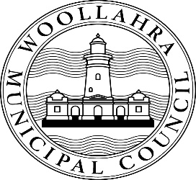
Inclusion (Disability, Aged and Carers) Advisory Committee
Expression of Interest Form

Before you fill out this form, please read the Terms of Reference for the Woollahra Inclusion (Disability, Aged and Carers) Advisory Committee, which can be found at yoursay.woollahra.nsw.gov.au/inclusion

Forms need to be submitted to Council no later than Monday 23 May 2021.

If you would like help to fill out this form, please call 9391 7058 or email community@woollahra.nsw.gov.au

- First name:

- Last name:

- Email:

- Phone number:

- Address:

- Please tick which of the following is true for you:
I have lived experience of disability
I am aged 70 years or above
I provide care for another adult
I provide care for a child living with disability

- Why would you like to join the Inclusion (Disability, Aged and Carers) Advisory Committee?

- Are you able to participate in 4 meetings each year for the next 2 years? Meetings will be held in June, September, December and March either online or in person at Council Chambers, 536 New South Head Road, Double Bay.
Yes
No
Not sure

How Council will decide who will be on the Inclusion (Disability, Aged and Carers) Advisory Committee?
Expressions of Interest will be evaluated based on answers to the above questions. Committee members must be a Woollahra resident who is able to actively participate in meetings of the Committee.

You can submit your form:
- by post to Woollahra Municipal Council, PO Box 61, Double Bay NSW 1360
- by hand to Customer Services at 536 New South Head Road, Double Bay 2028
- by email to records@woollahra.nsw.gov.au

